Doa'a Abdulkareem Aish Al-Jarrah
1/1/2021
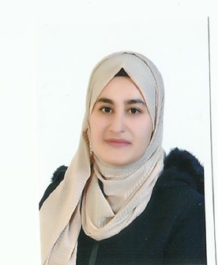 | Phone: +9962779571165  Email: doajarrah@gmail.com  Date of birth: 2/11/1993  Marital status: Single  City/Country : Jordan-Irbid

Objective
An organized professional with proven teaching, guidance and counseling skills. Possesses a strong track record in improving test scores and teaching effectively. Ability to work in teams and resolve problems and conflicts professionally. Has the ability to communicate complex information in a simple and entertaining Method. Looking to contribute my knowledge and skills in a school that offers a genuine opportunity for career progression.

Education
- 2012-2016 Bachelor degree in Special Education
Jadara University
- 2017-2019 Master degree in Special Education
Amman Arab University

experience
- Data entry with the International Relief Organization
- Feb-2019 – on going Blooming Academy
- Feb-2016 – Jan-2019 Abu Obaida Organization
- Mabrrat Al Hussein (volunteer for Two months)
Help the orphans of martyr’s sons
Teaching and care institution for Children living in hardship
Providing a safe environment and learning opportunities to help them attain a happy and fulfilling adult life
- 2011 – 2013 Volunteer at the Children Love Cultural Forum
Organized and engaged in recreational activities such as games and puzzles
Organized small groups of children while transitioning to and from outdoor play
Instructed, supervised children in class and assisted with marking and correcting work.
- 2011 - 2011 Volunteer at Protection of Family and Childhood Association.
Provide a support system for the children abuse investigation process
Create Children's Activities group and Develops own weekly activity planning.

SKILLS & ABILITIES

COMMUNICATION
- Experienced in Operating Microsoft word, Excel, and outlook.
- Great communication and problem solving skills.
- Not afraid to work in somewhat challenging areas.
- Strong organizational and analytical skills.
- Effective team player and able to work independently.
- Able to maintain strict confidentiality.
- Extensive typing, search Engines, internet, and social media experience.
- knowledge about data management and computer skills

TRAINING COURSES
- Wexler's test application for intelligence (1/12/2013-8/12/2013)
At Jadara University
- Diagnosis of learning difficulties (30/11/2014-11/12/2014)
At Jadara University
- Autism (20/12/2015-7/1/2016)
At Jadara University

LANGUAGES
- Arabic (Native)
- English: good command, both speaking and writing

